Table of Contents

Cleaning Company Project 1

Project Plan 1

1

Requirement Review 2

Process Flow 3

Design Considerations 4

Design Highlights 4

Deign Options Considered but not used 5

Option 1 5

Option 2 5

Design Components: 6

# Cleaning Company Project

Create a system for “Cleaning Company” managing a professional cleaning services company that operates on a major metropolitan area.

# Project Plan

* 1. The project will follow a 2 week accelerated development cycle using salesforce.com technology. The table below lists an estimated timeline for the project and key touch points with the client. The client is expected to review and approve the below time line.

## 

| # | Activity | Due Date | Status |
| --- | --- | --- | --- |
| 1 | Requirement Review and Signoff | 5/25/2016 | Send to Client on 5/24 |
| 2 | Initial Design Review and Signoff | 5/27/2016 | Send on 5/31 |
| 3 | Client access to Sandbox | 5/30/2016 | Set up on 5/31 |
| 4 | Review of Project build | 6/3/2016 |  |
| 5 | Signoff on the Sandbox | 6/3/2016 |  |

# Requirement Review

1. Based on the initial understanding of the requirements I have come up a number of questions and assumptions. Please update this document with your answers. This is important for me to proceed with the design of the system.

|  |  |  |
| --- | --- | --- |
| # | Requirement | Questions/Assumptions |
| 1 | Create a system for managing a professional cleaning services company that operates on a major metropolitan area | Assumption:  Cleaning Company intends to use salesforce.com as their Information system and has sufficient license for users.  Assumption:  Cleaning Company DC Metro Area will be used for the initial pilot of this system. |
| 2 | The job delivery unit is always cleaners per day. (e.g.: a private home owner hires one cleaner for one day, a large office hires three cleaners for one day) | Assumption:  There is no dependency on the equipment/cleaning supplies. The only factor that will be tracked in the system will be cleaners.  Question:  Is the number of cleaners per job fixed? Is there possibility that when customer orders a new job they ask for additional cleaners? |
| 3 | The jobs can be booked individually (ad-hoc) or with the following recurrences: weekly, bi-weekly or monthly | Question:  Is there any limit to the number of jobs that can be handled in a day?  How many employees does Cleaning Company have?  Can I assume 1 employee – 1 job/day, and a total of 12 employees |
| 4 | Payment method is always Credit Card. | Assumption:  For the initial version we are not doing any integration with Credit Card authorization service. |
| 5 | The standard rate is 180USD/cleaner/day, recurring jobs have a 10% discount | Assumption:  The orders are taken by a representative and data entered in the system. The representative will verify phone number in the account of the customer will be used to determine if the caller is a repeat customer. |
| 6 | The company employees works on commission, the gross revenue for each job is split 50/50 (50% is company revenue and 50% is the employee pay) The company needs to keep track of: 1. all booked and executed jobs 2 the total revenue generated and the number of jobs executed per client 3. the amount due and paid and the number of jobs executed by each cleaner | Assumption:  The system is only tracking the revenue and cleaner payment. No other expenses ( materials, office expenses, transportation expense etc) are tracked in the system. |
| 7 | Bonus: 1. A dashboard displaying the number of jobs executed and booked for the current week. 2. Display the client address (where the job will be executed on Google Maps) | Assumption: Initial version of the system will not be considered as mobile ready. Subsequent phases will address the mobility aspect of the application. |
| 8 | Extra Bonus: Consider the cleaners are paid every 1st and 15th of each month and design a system that accrues all jobs executed by each cleaner and keep track of all payments made to the cleaner. 1. All jobs executed between the 1st and the 14th of each month is paid on the 15th 2. All jobs executed between the 15th and last day of the month are paid on the 1st | Assumption:  The payment by the client will be automatically applied after the cleaning job is done. Initial release of the system will not be able to validate refunds to customer.  Assumption:  The Payment to the employees will be processed by the back-end accounting system and the initial version of the system does not include integration with the accounting system. |

# Process Flow

Based on the requirements a High Level Process Flow is defined as shown below

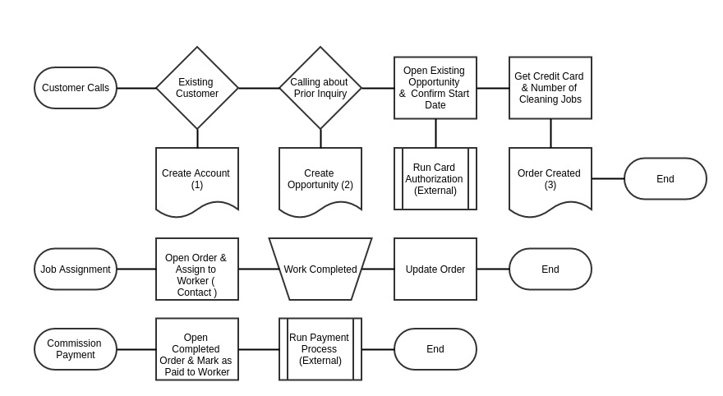

# Design Considerations

An Initial set of Design Considerations for the CleanCompany System is listed below

|  |  |
| --- | --- |
| # | Design Consideration |
| 1 | Salesforce.com Environment:  currently cleaning company does not intend to use any licenses for the cleaning workers. Only a handful of sales and order management team along with Management team will be the users of the system |
| 2 | Configuration vs Code:  The CleaningCompany does not have any development resources, so the configuration options in salesforce.com needs to be used whereever possible |
| 3 | Product Pricing and Configuration needs to be flexible for future changes to the system |
| 4 | BiWeekly Cleaning Service Order service is frequently asked. |

# Design Highlights

|  |  |  |
| --- | --- | --- |
| # | Design Component | Rationale |
| 1 | Account and Contacts  Use Standard Account Object to capture the customer Information and Contacts to capture the key personal, | This will keep the salesforce.com salescloud functionality as the core of the application and allow for easier future expansion. |
| 2 | Opportunity, Price Books and Product Catalog.  Opportunity Page will be used to capture the client needs and determine the price and staffing needs of the cleaning jobs. | Use standard salesforce Opportunity, Price Book and Products table to keep the Pricing information and to track customer opportunities and revenue booking process.  Design includes keeping a Discounted pricing book and additional customization of the Opportunity Product object to capture Job frequency for repeat orders. |
| 3 | Custom Record Type in Contacts to track all workers of the cleaningcompany | Rather than create a new object, leverage the recordtype feature of salesforce to track employees. This will allow for any future email communication on job assignment to workers. |
| 4 | Custom Job Object to capture the individual jobs and the job schedule | A new Job object is required to capture the individual work orders for tracking the job assignments and job status. |
| 5 | Custom Job Assignment Object to capture worker assignment to each Job instance | A junction object between Job and Contacts to capture worker assignment to each job. |
| 6 | Product -Quantity Schedule  The solution leverages Product – Quantity Schedule feature of salesforce.com to easily create schedule for the weekly, bi-weekly and monthly orders | The Out of box Quantity schedule is used to for leveraging out of the box functionality of salesforce and minimize custom development.  Design uses Flows – to address biweekly scheduling as flows can handle loop operations. |

## Deign Options Considered but not used

### Option 1

Use of Work Order Standard Object from Spring 16: Salesforce Work Order Standard Objects can be used for field services – but this is more beneficial if the field reps also have salesforce license. Since the license is limited we cannot go this route

### Option 2

Use of Order Standard Object:Salesforce Order object was considered in custom Job object. This would require additional customization of the Order Line object. However looking at the limited APIs exposed on the Order Line Object, custom Job Object was selected. Also, salesforce.com is only beta on opportunity to order conversation flows and may not be suitable. I also looked at Druvsoft – Opportunity to Order Converter app exchange product, but it could not handle opportunity line item schedules.

# Design Components:

|  |  |  |
| --- | --- | --- |
| # | Requirement | salesforce.com Build Components |
| 1 | Create a system for managing a professional cleaning services company that operates on a major metropolitan area | Application 'Cleaning Company' with tabs for Home, Accounts, Contacts, Opportunity, Job, Products, Reports and Dashboard  Custom record type “Employee” in contact for handling Employees. |
| 2 | The job delivery unit is always cleaners per day. (e.g.: a private home owner hires one cleaner for one day, a large office hires three cleaners for one day) | Custom Object call Job__C and Job_Assignment__C.  Job__C has Master-Detail with Accounts  Job__C has lookup with Opportunities  Job_Assignment__C is a junction table with Job and Contacts |
| 3 | The jobs can be booked individually (ad-hoc) or with the following recurrences: weekly, bi-weekly or monthly | Product has been configured to allow scheduling for quantity and schedule.  Product Family field customized for handling biWeekly processing  Created custom pricebook for Cleaning Company  Created a flow “[Create Job](https://sunskydemo.my.salesforce.com/300360000004wwb)s” to remove additional schedule and revenue entries from the OpportunityLineitemSchedule table to match the recurring visit count and to create biweekly recurrences from weekly recurrences. This flow also creates necessary Job Records. |
| 4 | Payment method is always Credit Card. | Created a flow - “[Capture Credit Card Authorization](https://sunskydemo.my.salesforce.com/300360000004wL5)” to get CC authorizations to be stored in Opportunity. |
| 5 | The standard rate is 180USD/cleaner/day, recurring jobs have a 10% discount | Created a discounted pricebook for recurring products with a 10% discounted price. |
| 6 | The company employees works on commission, the gross revenue for each job is split 50/50 (50% is company revenue and 50% is the employee pay) The company needs to keep track of: 1. all booked and executed jobs 2 the total revenue generated and the number of jobs executed per client 3. the amount due and paid and the number of jobs executed by each cleaner | Created formula fields and rollup summary fields in Job, Job_Assignment, Account and Contact tables to capture the booking count, revenue count and amount due and paid.  Created a process builder 'Update Commission' to make sure that when Job is marked as complete the commission and the amount due fields in job_assignments are also set. ( we have do this and cannot use formulae so that the Rollup Summary in Contacts to work) |
| 7 | Bonus: 1. A dashboard displaying the number of jobs executed and booked for the current week. 2. Display the client address (where the job will be executed on Google Maps) | Created two reports for relevant information and a dashboard to display the account level information and job assignments ( not showing data at week level because of the data limitations)  if the client address is a valid us address out of the box account page setup is able to show the address map |
| 8 | Extra Bonus: Consider the cleaners are paid every 1st and 15th of each month and design a system that accrues all jobs executed by each cleaner and keep track of all payments made to the cleaner. 1. All jobs executed between the 1st and the 14th of each month is paid on the 15th 2. All jobs executed between the 15th and last day of the month are paid on the 1st | Created a visual flow to capture the date and the time period – that updates the 'commission paid' flag in the Job records upon completion.  Created a VF page link to the above flow from home page component so the processing can be done quickly.  This can be changed to automate further |